Inheritance Tree Diagram
This is the Inheritance Tree Diagram of (Name of the Deceased) and is correct and complete in accordance with the provisions of Article 1138 to 1144 of the Civil Code. Should there be any misrepresentation that is sufficient to generate damage to the public or other, the applicant shall bear the liability.

Identity | Name | Date of Birth | Date of Death
Deceased
Note:
- If heirs are available to the preceding order of succession (i.e., not being dead or asserting waived succession), the heirs to the succeeding order then have no right to inherit and no need to be written down in this form. For example, if heirs are available to the first order of succession, the heirs to the second, third and fourth orders then need not to be filled in this form; if all heirs to the first order were either dead or asserted waived succession, the heirs to the second order have the right to inherit, and all the heirs to the first and second orders shall be written down in this form, and so forth.
- Please indicate the date of birth of each heir when filling out this form.
- Please indicate if any of the heir was dead or asserted waived succession when filling out this form.

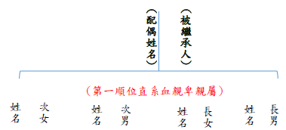
Heirs of the First：
Lineal Descendants by blood
Deceased
Name of Spouse
Name of the Second Son

Name of the Eldest Son

Name of the Eldest Daughter

Name of the Second Daughter

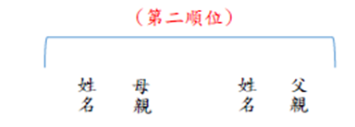
Heirs of the Second
Name of the Mother

Name of the Father

Heirs of the Third
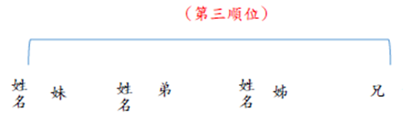

Name of the Younger Brother

Name of the Younger Sister

Name of the Elder Brother

Name of the Elder Sister

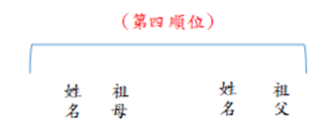
Heirs of the Fourth
Name of the Grandfather
Name of the Grandmother

Applicants (i.e., all heirs to the ____ order of succession mentioned above):
(Please sign and seal)
(Please sign and seal)
(Please sign and seal)
(Please sign and seal)
(Please sign and seal)

- Please attach Household Registration Cancellation Transcript of the deceased and Household Registration Transcript of the heirs issued in the recent three months.
- If an heir was dead or asserted waived succession, please attach Certificate of Death or Disclaimer of Right to Inheritance.

Date: (mm/dd/yyyy)

